Novo WebPort® Quick Start 1

Introduction

This Quick Start provides an overview of the Novo WebPort development environment to get you started using the product right away. It also tells you where to look for details about the tools and features available in WebPort.

Chapter 2, “A tour of the desktop” describes the main tools on the WebPort desktop, or integrated desktop environment (IDE). Chapter 3, “Managing with WebPort” explains how you use some of these tools to create a managed website. Chapter 4, “Creating a managed website—a tutorial” takes you step by step through a tutorial to create all the controls for your website complete with a webshop ready for activation the moment you complete the tutorial. Chapter 5, “Customizing the desktop” describes how you can customize the WebPort IDE for your development needs.

What is WebPort?

WebPort is an object-oriented, visual programming environment for rapid intranet and internet application development (RIAD). Using WebPort, you can create highly efficient applications and program templates with robust data-connectivity layers for Microsoft Internet Information Services (IIS) and Microsoft SQL with a minimum of manual coding. WebPort also provides a simple cross-platform solution when used in conjunction with Cylix, NovoPort’s RIAD tool for Macintosh OSX and Xylix, a RAID tool for Linux using the Mono Framework. WebPort provides all the tools you need to develop, test, and deploy applications, including a large library of reusable components with the ability to be expanded as you need them, a suite of design tools for your innovative ideas, webform templates, and programming wizards.

Finding Information

You can find information on WebPort in the following ways, described in this chapter:

● Online Help
● Printed documentation
● NovoPort developer support services and Web site

For information about new features in this release, refer to What’s New in the online Help Contents and to the www.novoport.com Web site.

Online Help

The online Help system provides detailed information about user interface features, object and control implementation, programming tasks, and the components in the Visual Component Library Reference (VCL). It includes all the material in the WebPort Developer’s Guide and a host of Help files for other features bundled with WebPort such as the Module Developer’s Package (MDP).

To view the table of contents, choose Help | WebPort Help and Help | WebPort Tools, and click the Contents tab. To look up VCL or MDP objects or any other topic, click the Index or Find tab and type your request.

Printed documentation

This Quick Start is an introduction to WebPort. To order additional printed documentation, such as the Module Developer’s Guide, refer to shop.novoport.com.

Developer support services and Web site

NovoPort also offers a variety of support options to meet the needs of its diverse developer community. To find out about support, refer to http://www.novoport.com/devsupport/.

From the Web site, you can access many newsgroups where WebPort developers exchange information, tips, and techniques. The site also includes a list of books about WebPort, additional WebPort technical documents, and Frequently Asked Questions (FAQs).

Typographic conventions

This manual uses the typefaces described below to indicate special text.

Table 1.1 Typographic conventions
Typeface | Meaning
Monospace type | Monospaced type represents text as it appears on screen or in code. It also represents anything you must type.
Boldface | Boldfaced words in text or code listings represent reserved words or compiler options.
Italics | Italicized words in text represent WebPort identifiers, such as variable or type names. Italics are also used to emphasize certain words, such as new terms.
Keycaps | This typeface indicates a key on your keyboard. For example, “Press Esc to exit a menu”.

2

A tour of the desktop

This chapter explains how to start WebPort and gives you a quick tour of the main parts and tools of the desktop, or integrated desktop environment (IDE).

Starting WebPort

You can start WebPort in the following ways based on your installation. The most common, using IIS on a local machine:

● Open Internet Explorer and type into the address box http://localhost/WebPort/admin.
● If you have installed on an intranet server,
● maybe another

The IDE

When you first start WebPort, you’ll see the login screen:

Figure 2.1 The Login Screen
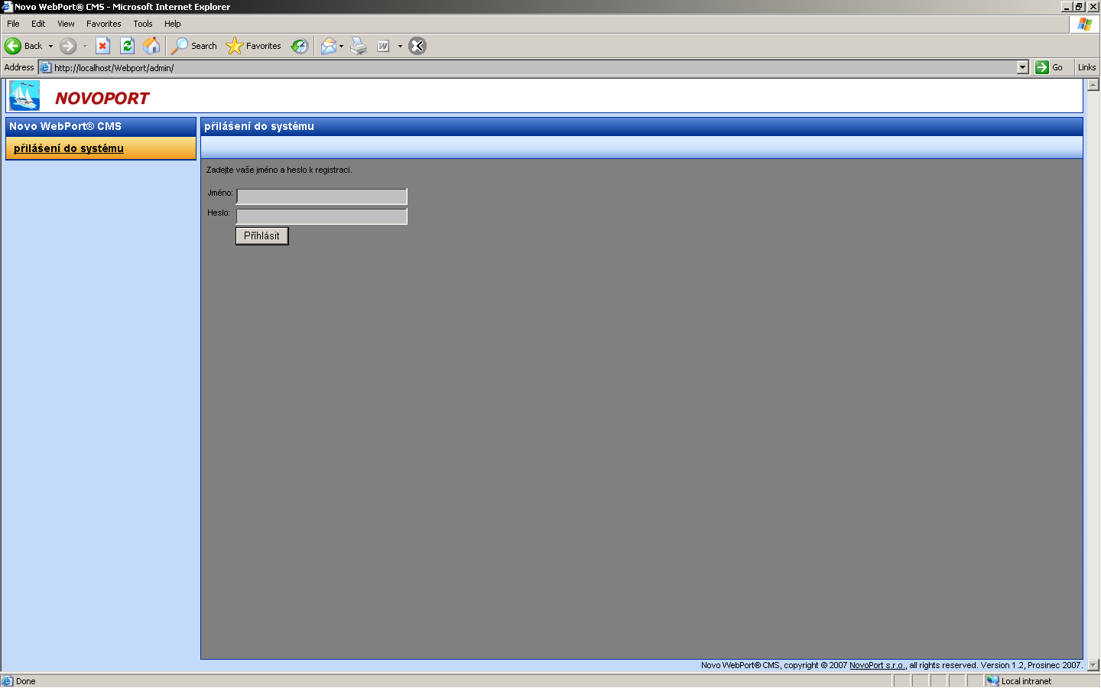

Input the username and password provided to you when you purchased the product and after clicking “Login”, you will see the main desktop.

Figure 2.2 The Main Desktop
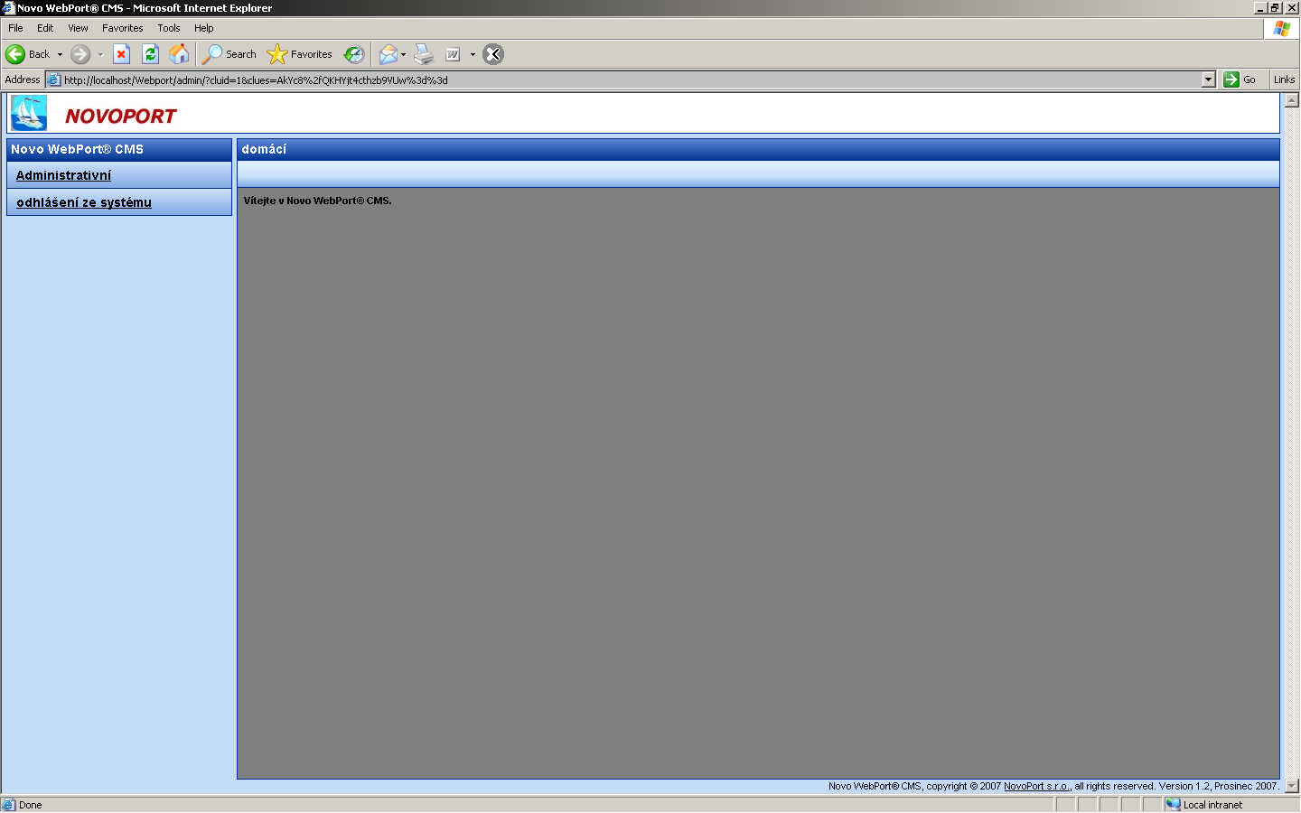

Continue…

